

Ref. No. 115/23-24 Date: 10-11-2023

**NOTICE**

This is for all concerned that Prof. Joyeeta Mukherjee, Assistant Professor, Philosophy will remain as Teacher-In-Charge of the college for today, i.e., November 10, 2023

.

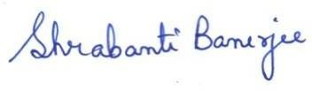 **(Dr. Shrabanti Banerjee)**

**Principal, Jamalpur Mahavidyalaya**

**Jamalpur, Purba Bardhaman**